Mid-term Scientific Report

KoEF Research Cooperation Project

Project Overview
Project Title
Acronym
Project Number
Cooperating Countries
Reporting Period
Coordinating Institution
Project Coordinator
Email Coordinator
Partner Institution 1
Project Co-Coordinator
Email Co-Coordinator
Please insert lines for further partners.

No. of All Involved Institutions
Austrian Institutions
Partner Country Institutions
Project Duration
Duration in Months
Total Costs Applied (€)
No. of Team Members  (including Coordinator) | Male: | Female: |  | Total:
Coordinating Institution  (including Project Coordinator) | Male: | Female: |  | Total:
Partner Institution 1  (including Co-Coordinator) | Male: | Female: |  | Total:
Please insert lines for further partners.

Branch(es) of Science  (max. 3) | Branch Name |  | Six-Digit Code
Contribution to SDGs  (max. 3) | Name of SDG |  | SDG Number

Content

Project Overview 1
1. Abstracts 3
2. Narrative summary of the project 4
2.1. Overview of completed and started work packages 5
2.2. Complete list of funded mobilities (research stays) 5
2.3. Reports on research stays of project members 5
3. Reflection on the partnership and cooperation between researchers and institutions 6
4. Contribution to the SDGs, Implementation of Gender and Diversity Issues 7
5. Difficulties, Mitigating Measures 8

Funded by:

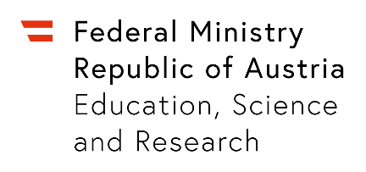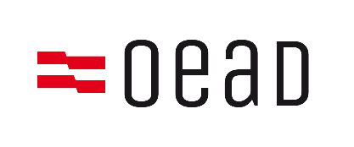

Abstracts
Please provide a brief abstract of the project in English and German (ca. 500 words each)

Narrative summary of the project

Overview of completed and started
work packages

Complete list of funded mobilities (research stays)

Reports on research stays of project members

Reflection on the partnership and cooperation between researchers and institutions

Contribution to the SDGs, Implementation of Gender and Diversity Issues

Difficulties, Mitigating Measures

http://www.statistik.at/kdb/downloads/pdf/OEFOS2012_EN_CTI_20190903_162012.pdf
https://sustainabledevelopment.un.org/sdgs

